Document Type
1 – History & Physical
2 – Consult Note
3 – Progress Note
4 – Discharge Summary
5 – General Letter
6 – Insurance Letter
7 – Ministry of Transport Letter
19 – Wound Consult
Dictation Instructions
Internally Dial x2999
Externally Dial 833-279-3730

1. When prompted, enter your user ID and press #.
2. Enter a Document Type (below) and press #.
3. Enter a MRN (HI#) and press #.
4. Please dictate the date of service and account number
5. Press 2 to Record, 7 to Pause/Stop, and 8 to finish the report and start another.
6. Press * to replay confirmation number, while at first prompt, after completing a dictation.

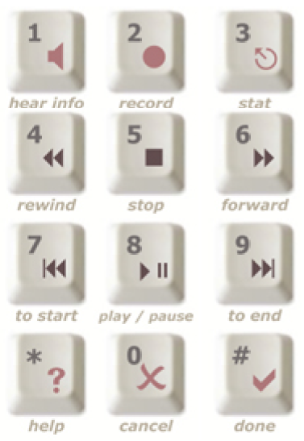

Discharge Summary Template
Please Dictate Each Heading
Most Responsible Diagnosis
Chief Complaint
Course in Hospital
Investigations
Lab
Radiology
Interventions/Treatment
Pre-existing Conditions
Developed Conditions
Past Medical History
Medications
Admissions
Discharge
Discharge Planning
Instructions
Plans
Referrals
Copies To

