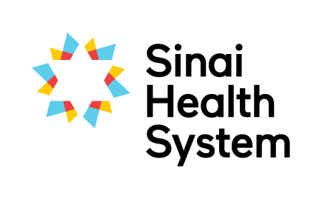
Excellence in Education Awards

Lifelong Learner Award - Nomination Form
The successful nominee is a lifelong learner who shares their learning generously with others and makes continuous efforts to advance their own knowledge and skills. Their enthusiasm for continuous learning influences others to do the same in order to grow personally and professionally.
Your name:
Your email:
Your phone number:
Are you: □ current student □ former student □ staff member □ academic partner
Which site are you at? □ Bridgepoint □ Mount Sinai
Nominees can choose to receive an extract of this nomination. As nominator would you prefer to: □ remain anonymous? or □ disclose your name?
Name of nominee:
Nominee’s team or unit:
Nominated team’s hospital site: □ Bridgepoint □ Mount Sinai
Email of nominee:

Below, please detail why you are nominating this person. Provide specific examples where possible to assist the selection committee in determining the awardee.
Models excellence and is considered a knowledge expert in their field; actively shares that knowledge using a variety of methods (e.g. teaches or shares knowledge with staff using a variety of methods)

Sustained involvment in continuing professional development or training that enhances their work (e.g. courses, diplomas, post-graduate education, workshops, conferences, presentations, publications)

Incorporates learning and feedback from peers, learners and professional relationships to innovate and improve practice (e.g. seeks professional relationships with others and encourages feedback)

Involved in external activities related to their profession (e.g. regulatory colleges, professional associations, interest groups)

Please submit the completed form electronically to Elisabeth.despres@sinaihealth.ca
If you have questions about the nomination and selection process, or need any guidance on completing this form please don’t hesitate to contact Beth Despres, Interprofessional Education Specialist at x2167 or Elisabeth.despres@sinaihealth.ca

