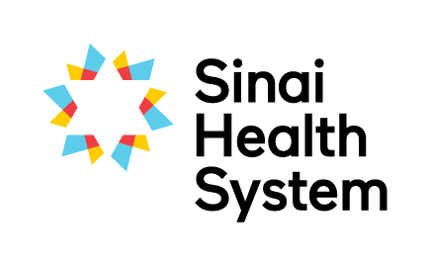
Excellence in Education Awards

Leadership in Education Award – Nomination Form
The successful nominee will have helped to foster a culture where clinical education is valued, through their commitment to the education of students, staff, patients and families, nurturing interprofessional collaboration and their active support of others to grow as teachers.

Your name:
Your email:
Your phone number:
Are you: □ current student □ former student □ staff member □ academic partner
Which site are you at? □ Bridgepoint □ Mount Sinai
Nominees can choose to receive an extract of this nomination. As nominator would you prefer to: □ remain anonymous? OR □ disclose your name?
Name of nominee:
Nominee’s team or unit:
Nominated team’s hospital site: □ Bridgepoint □ Mount Sinai
Email of nominee:

Below, please detail why you are nominating this person. Provide specific examples where possible to assist the selection committee in determining the awardee.
Fosters a culture where learning is valued (e.g. works to support the student experience)

Leads others in their growth as clinical educators and sustained commitment to improving the student experience (e.g. leads others in their growth as clinical educators, committed to development of own self as teacher)

Creates opportunities for exposing students to Interprofessional Practice (e.g. leads in creating opportunities to interprofessional practice)

Involvement in projects that advance clinical education at Sinai Health (e.g. curriculum development, workshops, research, involved in projects that advance clinical education for staff, students, patients and families)

Role models the values of Sinai Health System (i.e. Person Centred care, Excellence, Accountability, Collaboration, Equality, Innovation)

Please submit the completed form electronically to katherine.brown@sinaihealthsystem.ca or by mail to the Academic Office, Room AM.07, Bridgepoint Site.
If you have questions about the nomination and selection process, or need any guidance on completing this form please don’t hesitate to contact Robyn Davies, Interprofessional Education Specialist at robyn.davies@sinaihealthsystem.ca, Katherine Brown, Academic Coordinator at katherine.brown@sinaihealthsystem.ca.

