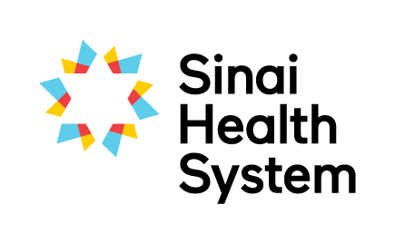
Excellence in Education Awards

Distinguished Educator Award - Nomination Form
The successful nominee is an excellent teacher who has gone above and beyond in their contribution to learning through their commitment to students, staff, patients and families and through valuing interprofessional collaboration at Sinai Health.
Your name:
Your email:
Your phone number:
Are you: □ current student □ former student □ staff member □ academic partner
Which site are you at? □ Bridgepoint □ Mount Sinai

Nominees can choose to receive an extract of this nomination. As nominator would you prefer to: □ remain anonymous ? or □ disclose your name?
Name of nominee:
Nominee’s team or unit:
Nominated team’s hospital site: □ Bridgepoint □ Mount Sinai
Email of nominee:

Below, please detail why you are nominating this person. Provide specific examples where possible to assist the selection committee in determining the awardee.
Sustained commitment to clinical education (e.g. supervises students regularly, supports clinical education for staff, students, patients and families)

Is an excellent role model (e.g. models best practice with students, committed to the development of their own skills as a teacher and clinician)

Provides feedback the encourages growth and reflection (eg. gives feedback that encourages growth,)

Integration of students into team; promotes interprofessional practice to students (e.g. integrates student into the team, encourages student to make interprofessional connections outside their immediate colleagues, models interprofessional behaviour)

Involved in projects/research with or about students (e.g. working on action research, working with the LTRI/Collaboratory, presenting at conferences, working with students on their projects, collaborating with other staff in research)

Please submit the completed form electronically to katherine.brown@sinaihealthsystem.ca or by mail to the Academic Office, Room AM.07, Bridgepoint Site.
If you have questions about the nomination and selection process, or need any guidance on completing this form please don’t hesitate to contact Robyn Davies, Interprofessional Education Specialist at robyn.davies@sinaihealthsystem.ca, Katherine Brown, Academic Coordinator at katherine.brown@sinaihealthsystem.ca.

