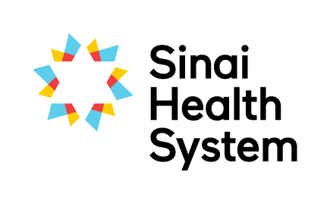

Excellence in Education Awards

Collaboration in Education Award – Nomination Form
The successful team (either from one profession or across professions) has made an active contribution to student clinical education at Bridgepoint or Mount Sinai through their commitment to students and fostering interprofessional collaboration.
Your name:
Your email:
Your phone number:
Are you: □ current student □ former student □ staff member □ academic partner
Which site are you at? □ Bridgepoint □ Mount Sinai
Nominees can choose to receive an extract of this nomination. As nominator would you prefer to: □ remain anonymous? OR □ disclose your name?
Name of nominated team or service:
Nominated team’s hospital site: □ Bridgepoint □ Mount Sinai
Name of contact person for team (e.g. manager, team leader):
Email of contact person:

Below, please detail why you are nominating this team. Provide specific examples where possible to assist the selection committee in determining the awardees.
Sustained commitment to clinical education (e.g. sustained supervision of learners, regularly offers shadowing experiences.)

Please comment on the team’s ability to integrate learners into the team and model the Interprofessional Collaborator Competencies (i.e. Patient Centered Care, Collaborative Leadership, Interprofessional Communication, Role Clarification, Interprofessional Conflict Resolution and Team Functioning)

Involved in projects that advance clinical education (e.g. IPE structured placements, conferences, presentations, workshops and research)

Please submit the completed form electronically to katherine.brown@sinaihealthsystem.ca or by mail to the Academic Office, Room AM.07, Bridgepoint Site.
If you have questions about the nomination and selection process, or need any guidance on completing this form please don’t hesitate to contact Robyn Davies, Interprofessional Education Specialist at robyn.davies@sinaihealthsystem.ca, Katherine Brown, Academic Coordinator at katherine.brown@sinaihealthsystem.ca.

