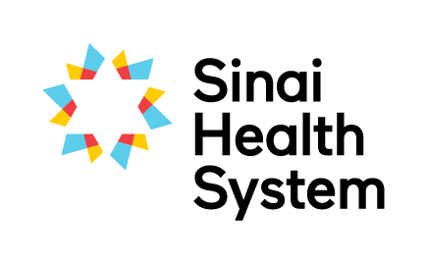
Excellence in Education Awards

Lifelong Learner Award - Nomination Form
We are looking for two individuals for our Lifelong Learner award. The winner is a lifelong learner who shares their learning generously with others and makes continuous efforts to advance their own knowledge and skills. Their enthusiasm for continuous learning influences others to do the same in order to grow personally and professionally.
Your name:
Your email:
Your phone number:
Are you: □ current student □ former student □ staff member □ academic partner
Which site are you at?
Name of nominee, name of their unit or service and their hospital site

Below, please detail why you are nominating this person. Nominees do not need to excel in all areas. Provide specific examples where possible to assist the selection committee in determining the awardee.
Involved in continuing professional development or training that enhances their work (e.g. courses, diplomas, post-graduate education, workshops, conferences, presentations, publications)

Considered a knowledge expert in their field and actively shares that knowledge (e.g.. teaches or shares knowledge with staff using a variety of methods, seeks professional relationships with others and encourages feedback)

Involved in external activities related to their profession (e.g. regulatory colleges, professional associations, interest groups)

Please submit the completed form electronically to Interprofessional.Education@sinaihealthsystem.ca or by mail to the Academic Office, Room AM.07, Bridgepoint Site.
If you have questions about the nomination and selection process, or need any guidance on completing this form please don’t hesitate to contact Robyn Davies, Interprofessional Education Specialist at robyn.davies@sinaihealthsystem.ca, Katherine Brown, Academic Coordinator at katherine.brown@sinaihealthsystem.ca.

