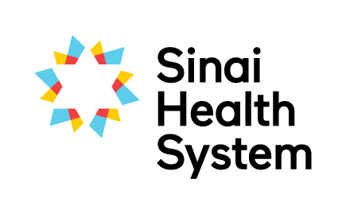
Excellence in Education Awards

Leadership in Education Award – Nomination Form
Each year we seek nominations for individuals for two Leadership in Clinical Education awards. The successful nominees will have helped to foster a culture where clinical education is valued, through their commitment to the education of students, staff, patients and families, nurturing interprofessional collaboration and their active support of others to grow as teachers.

Your name:
Your email:
Your phone number:
Are you: □ current student □ former student □ staff member □ academic partner
Which site are you at?

Name of nominee, name of their unit or service and their hospital site

Below, please detail why you are nominating this person. Nominees do not need to excel in all areas. Provide specific examples where possible to assist the selection committee in determining the awardee.
Fosters a culture where learning is valued (e.g. supports others in their growth as clinical educators, involved in projects that advance clinical education for staff, students, patients and families)

Works to support the student experience (e.g. integrates students into the team, exposes them to the interprofessional practice)

Committed to the development of their own skills as a teacher (e.g. participates in conferences, research or workshops)

Please submit the completed form electronically to Interprofessional.Education@sinaihealthsystem.ca or by mail to the Academic Office, Room AM.07, Bridgepoint Site.
If you have questions about the nomination and selection process, or need any guidance on completing this form please don’t hesitate to contact Robyn Davies, Interprofessional Education Specialist at robyn.davies@sinaihealthsystem.ca, Katherine Brown, Academic Coordinator at katherine.brown@sinaihealthsystem.ca.

