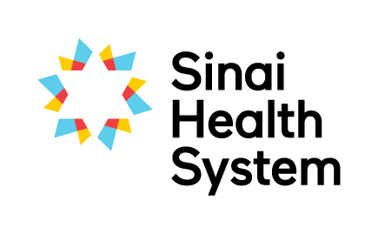
Excellence in Education Awards

Distinguished Educator Award - Nomination Form
Every year we seek nominations for four individuals to receive the Distinguished Educator Award. The successful nominees will have gone above and beyond in their contribution to student clinical education through their commitment to students, staff, patients and families and through fostering interprofessional collaboration and innovation.
Your name:
Your email:
Your phone number:
Are you: □ current student □ former student □ staff member □ academic partner
Which site are you at?

Name of nominee, name of their unit or service and their hospital site

Below, please detail why you are nominating this person. Nominees do not need to excel in all areas. Provide specific examples where possible to assist the selection committee in determining the awardee.
Sustained commitment to clinical education (e.g. supervises students regularly, gives feedback that encourages growth, models best practice with students, supports clinical education for staff, students, patients and families)

Promotes interprofessional practice to students (e.g. integrates student into the team, encourages student to make interprofessional connections outside their immediate colleagues, models interprofessional behaviour)

Committed to the development of their own skills as a teacher and clinician (eg. participates in conferences, research or workshops)

Involved in projects that advance education at Bridgepoint or Mount Sinai in any area (e.g. working on action research, working with the LTRI/Collaboratory, presenting at Conferences, working with students on their projects, collaborating with other staff in research)

Please submit the completed form electronically to Interprofessional.Education@sinaihealthsystem.ca or in by mail to Interprofessional Education, Room AM.07, Bridgepoint Site.
If you have questions about the nomination and selection process, or need any guidance on completing this form please don’t hesitate to contact Robyn Davies, Interprofessional Education Specialist at robyn.davies@sinaihealthsystem.ca, Katherine Brown, Academic Coordinator at katherine.brown@sinaihealthsystem.ca.

