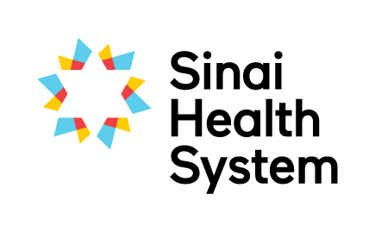

Excellence in Education Awards

Collaboration in Education Award – Nomination Form
We are looking for two teams to award our Collaboration in Education Award. The successful teams (either from one profession or across professions), have made an active contribution to student clinical education at Bridgepoint or Mount Sinai through their commitment to students, and fostering interprofessional collaboration and innovation.
Your name:
Your email:
Your phone number:
Are you: □ current student □ former student □ staff member □ academic partner
Which site are you at?
Name of nominated team or service and their hospital site

Below, please detail why you are nominating this team. Nominees do not need to excel in all areas. Provide specific examples where possible to assist the selection committee in determining the awardees.
Sustained commitment to clinical education (e.g. supervises students regularly, offers shadowing experiences.)

Promotes interprofessional practice to students (e.g. integrates student into the team)

Involved in projects that advance clinical education at Bridgepoint or Mount Sinai (e.g. conferences, presentations, workshops and research)

Please submit the completed form electronically to Interprofessional.Education@sinaihealthsystem.ca or by mail to the Academic Office, Room AM.07, Bridgepoint Site.
If you have questions about the nomination and selection process, or need any guidance on completing this form please don’t hesitate to contact Robyn Davies, Interprofessional Education Specialist at robyn.davies@sinaihealthsystem.ca, Katherine Brown, Academic Coordinator at katherine.brown@sinaihealthsystem.ca.

